Photo | Total Price | Price per Unit L.E | QTY | Unit | Item
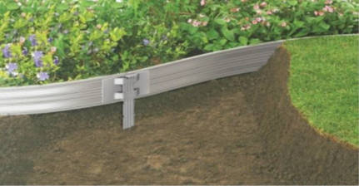 |  | 268 | 1M | LM | Aluminum Edging  (GAR 6X)
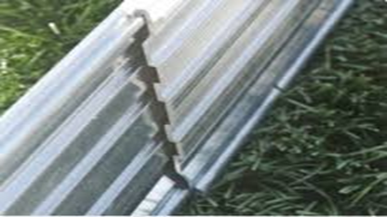 |  | 105 | 1M | LM | Landscape edge  GAR 5" Slide
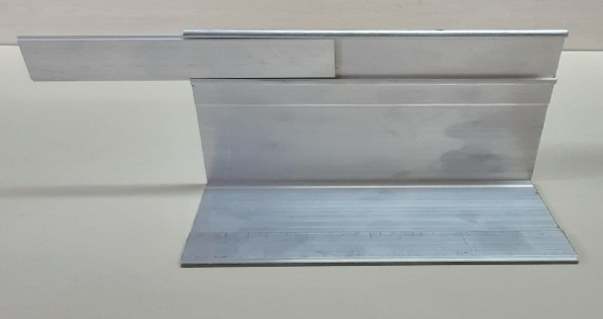 |  | 148 | 1M | LM | Landscape Edge Gar 4L
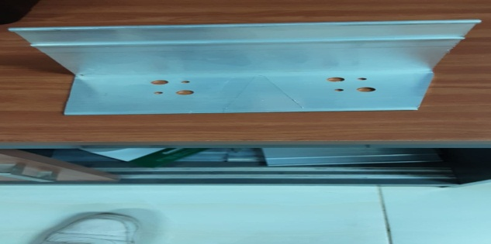 |  | 218 | 1M | LM | Landscape Edge Gar 4L PFC
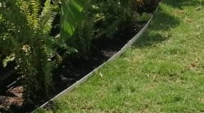 |  | 67 | 1M | LM | Landscape Edge Gar 55T

Offer Conditions:-
- Prices not include any taxes.
- Prices not include site delivery and installation.

- Payment terms:
- If in stock: 100% upon receipt.
- If not in stock: 50% Down Payment – 50 % upon receipt.

- Manufacturing Time: 2-3 Weeks From Down Payment.

- Offer Validity: 7 days from offer date.

For any further inquiries please do not hesitate to contact.

Supporting Team
Eng – Ahmed Shaban

