Ahmed Hamdy Abd Elhalim Mabrouk | 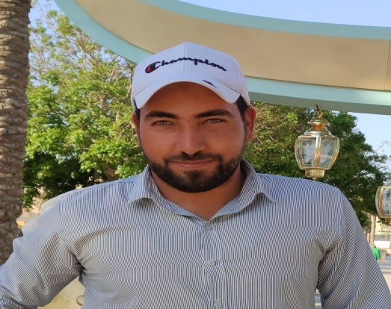

Personal information |  | - Nationality :- Egyption  - Date of birth :- 25 – 8 – 1991  - Marital status :- Married  - Religion :- Muslim  - Military status :- Finished

Contact Details |  | - Place of birth :- Ashmoun – menoufia  - Cell Phone :- 01025308253  - Email :EngAhmedHamdy0@YAHOO.COM

Education |  | - Faculty of Agriculture - AL Azhar University  - Graduation Year :- 2013

Work Experience |  | - Current job :- Working as a project manager At scientific office Land scape Company At Cairo Festival city ( from 12 – 2019 Till Now )  - Worked as Agriculture Engineer At Palmera Company At Cairo Festival city From ( 5 – 2017 TO 12 – 2019 )  - Worked as Agriculture Engineer At Vert Absoulo Company ( From 6 -2016 To 5 -2017 ) At  - Up Towne Cairo  - Hyde Park  - Cairo Festival City  - Worked as Agriculture Engineer At Target Company ( From 12-2015 TO 5-2016 ) At  - Hayat Regency  - Up Town Cairo

Courses |  | - Preparation Of a professional Landscape Engineer For Construction Projects  - ICDL

Skills |  | - The ability to work in team work  - The ability to create and innovate new ideas for development the work  - The ability to communicate and deal other and build relationships to serve the work  - The ability to work under pressure and for a long hours  - Good of both Written And spoken English

