**Emad AbdelSamea** 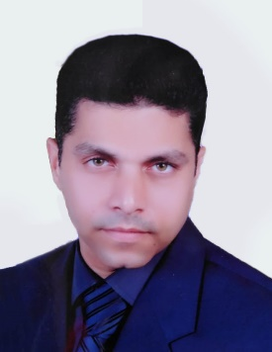

Contact Information 22, the second area , El sherouk city , Cairo, Egypt

Mob. :- +201115010571

Email: [emadmoh1581971@gmail.com](mailto:emadmoh1581971@gmail.com)

|  |  |  |  |
| --- | --- | --- | --- |
|  | | |  |
| **Objective:**  My name is Emad Abdelsamea,  A Certified Public Accountant (CPA) with 10+ years of experience in public accounting and financial auditing,  have a great knowledge of (ERP) system, had Personal Skills Development Certification from KCC, completed  certified sales course from AUC.  Looking for an opportunity in a fast growing company to build out best accounting practices and make  accounting a competitive advantage within the organization. | | | +20121077830 |
| **Work experiences:**  **United farms ( Mesr Alexandria desert road, 107 km) “consultative”**   * Prepare daily, monthly and annual financial statements and reports. * Maintain financial database by using financial software computer systems. * Interact with internal and external auditors in completing audits. * Resolve accounting discrepancies. * Control bills and invoices. * Dealing with company’s bank accounts. * Support month-end and year-end close process   **Vibe Gym Finance Manger, 15/01/2010 – till now**   * Prepare daily, monthly and annual financial statements and reports. * Maintain financial database by using financial software computer systems. * Interact with internal and external auditors in completing audits. * Resolve accounting discrepancies. * Control bills and invoices. * Dealing with company’s bank accounts. * Support month-end and year-end close process * Other related jobs assigned to me.   **Empire Holding Company, Accountant, 01/08/2010 till 28/2/2011**  **Responsibilities:**   * Cashier. * Prepare daily financial report. * Maintain financial database by using financial software computer systems. * Interact with internal and external auditors in completing audits. * Resolve accounting discrepancies. * Control bills and invoices. * Dealing with company’s bank accounts. * Other related jobs assigned to me.   **Sahab Airlines, Accountant, 27/01/2008 till 31/07/2010**  **Responsibilities:** same as mentioned above.  **Free Business, Accountant and assistant, 01/01/2002 till 31/10/2008**  **Responsibilities:**   * Dealing with all bank accounts. * Dealing with customs officially. * Dealing and finishing all required documents with all governmental offices.     **Excel for Water Mixer, Sales, 05/03/2000 till 05/12/2001**  **Responsibilities:**   * Selling water mixers throughout the whole Egyptian Governorates     **El Pharana Ceramics, Sales, 05/06/1997 till 09/01/2000**  **Responsibilities:**   * Selling Ceramic throughout the whole Egyptian Governorates     **Qualifications and skills:**   * Bachelor of Commerce, Accounting, Cairo University. * Deal with ERP system (SAP) * MS Office * VP * Sales Course, From AUC * Personal Skills Development, from KCC * Training with “the Egyptian group For Accounting & auditing”   **Language:**   * **English** (medium level) |  |  | |

All documents are furnished upon request