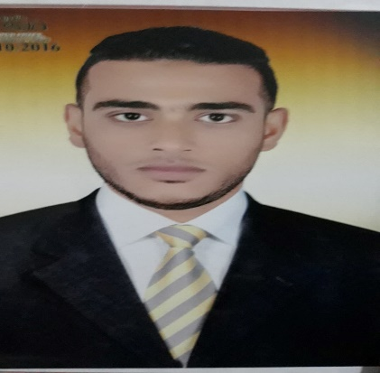***Personal Data:***

***Name***  : Tarek Riad Mohamed

***Nationality*** : Egyptian

***Date of Birth*** : 16/12/1990

***Present Address*** : Qena - Egypt

***E MAIL***  : sir.t.reyad@gmail.com

***Mobile No.***  : 01101595951_01030376262

***Marital Status*** : Single.

**Education:**

* **Master's degree in civil law,** AssiutUniversity 2018
* Holds a special law diploma from Assiut University 2017
* Bachelor of Law : South Valley University
  + Graduation year: 2012
  + Overall degree: acceptable

***Objective:***

|  |
| --- |
| To be a part of a progressive firm offering opportunity for career advancement and Professional growth and which will help me gain sufficient knowledge |

**Computer skills:**

MS Office, expert internet navigator

**Personal skills:**

**Expert** Internet navigator, hard worker under stress and team leader player

Able to comprehend new skills quickly

Able to work efficiently with different team across an organization

Strong analytical and practical problem solving

Possess mathematical foundation and possess hardworking capabilities

Willing to relocate and adapt with multicultural environment

***Language Spoken:***

* Arabic : Mother Tongue
* English : Good