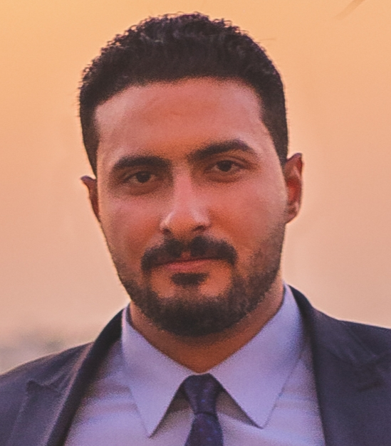

**Address : 57th El salam street Ainshams , Cairo , Egypt .**

**E-mail shawkysaleh06@gmail.com**

**Mobile : +20-11- 42390270 .**

**Personal Data :**

▪ **Name** : Shawky Hassan Shawky Saleh.

▪ **Date of Birth**  : January 1st , 1993.

▪ **Gender** : Male .

▪ **Relgion**  : Muslim.

▪ **Nationality** : Egyptian.

▪ **Military** : Exempted.

▪ **Marital status** : Single.

**Education :**

* Date Of Graduation : Septemper, 2015
* Bachelor Degree of Foreign Trade Economics Department
* Faculty : Commerce
* University : Helwan
* Final Year Grade : Good .
* Graduation Grade : Acceptable .
* May , 2009 : General Secondary Certificate From Ain Shams School - Graduation Degree : 80% .

**Languages :**

|  |  |  |
| --- | --- | --- |
| **Arabic**  Native | **English**  Reading : Good  Writing : Good  Speaking : Average | **German**  Reading : Good  Writing : Average  Speaking : Average |

**Work Experience:**

|  |  |
| --- | --- |
| Previous Job : | * **Position** : Property insurance specialist. * **Company :** Eid selim – Lawyering firm. * **Duties :** Vehicles insurance , accidents insurance inspection including information documents extraction and pursuing the insurance documents of the concerned personnel. * **Duration :** From 2010 till 2015 |
| Previous Job : | * **Position** **:**  Documentation specialist. * **Company :** Misr insurance company. * **Duties :** Sales management and Public relations . * **Duration :** From ( January – 2015 ) till ( January – 2016 ) . |
| Previous Job : | * **Position :** Documentation specialist. * **Company :** Media fire – Contracting firm. * **Duties :** Financial and documentation management. * **Duration :** From ( October – 2018 ) till (December 2018 ). |
| Previous Job :  Previous Job : | * **Bank Audi**. * **Position:** sales management. * **Duration :** From ( November – 2019 ) till (September – 2020 ) * **Chubb Life** * **Position sales maangment** * **Duration : From (January - 2021) till ( October - 2021).** |
|  |  |

**General Skills:**

|  |  |
| --- | --- |
| Communication Skills | Good |
| Computer Skills | Good |

**Personal Skills and activities:**

* Boxing and weight lifting.

**A few Words about myself:**

* Quick learner , excellent people and communication skills , ambitious and ready.