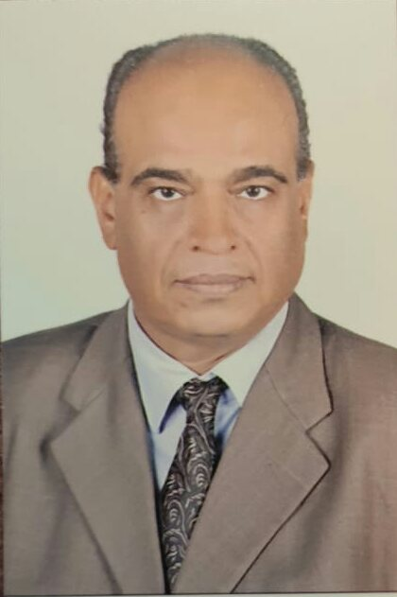
Hussein Zein Elabdien Hussein |

Phone: +2 01069780543
Email: husseinezzelaraib@yahoo.com
Address: 14 Desoki street, behind the Constitutional Court, Maadi, Cairo

Personal Information
Date of birth: 5/3/1968
Marital Status: Married
Gender: Male
Nationality: Egyptian

Career Objective
A challenging career opportunity in the field of Technical Support that utilize my previous work experience, academic background, and my skills. I am a Technical Administrator with twenty-one years’ experience in the Technical Administration. I am competent with Microsoft Office applications (Word, Excel, and PowerPoint) and using the Internet. In my past roles I have handled a full range of office and admin work, organizing more than 400 events in the field day, seminars, and retailing. Making travel arrangements, managing diaries, basic bookkeeping, filing, and copying. I can work both independently and as a part of a team. Seeking a suitable position that utilize my previous experience and my computer skills, fulfill my personal ambition, and enhances my knowledge.

Educational Background
Cairo University
Bachelor of Commerce,
Major: Business Administration
Minor: Marketing

Extra Courses
2019
Certificate of Attendance Application Training, Amman, Jordan (Seminar)
2017
The Egyptian Road Safety training program for the category passengers Car-Road safety Education
2017
Safe and effective use of pesticides – at the level of Egypt
2016
Safe and effective use of pesticides – at the level of Africa & Egypt.

Work Experience
Technical ADMINSTRATOR – Syngenta Agro.Egypt
Technical Support department
2013-2020

-Syngenta is a leading international company in Egypt market, which works in both corp. protection and seeds sector and cover a wide range from farmers needs in all segments.

Responsibilities:
- One of the Crop Protection Development (CPD) team who do activities and recourses in the commercial unit in Egypt.
- Supervise some development and commercial pesticides trials.
- Sending reports of development and commercial pesticides trials to AME team.
- Presenting and discussing some of CPD parts monthly with CPD members.
- Creating save-use pesticides presentations.
- Organizing events in the field-day, seminars, and retailing.
- Working both independently and as part of a team, as and when required
- Full range of general clerical work such as filing, photocopying, scanning, and faxing.
- Accurate and efficient data entry.
- Answering email and phone queries.
- Managing and updating the company’s databases and lists.
- Greeting visitors at events, showing them to meeting rooms & preparing refreshments.
- Managing calenders for the department.
- Booking travel and accommodation for the events, seminars, and courses.
- Maintaining training, sickness, and annual leave records.
Administrative assistant – Syngenta Agro.Egypt
Sales department
2005– 2013

Responsibilities:

- Organizing events in the field-day, seminars, and retailing.
- Managing eligibility to work checks/documents.
- Handling enquires from both job seekers and client companies.
- Ensuring meeting rooms were tidy and well stocked.
- Monitoring and replenishing office consumables on a regular and systematic basis.
- Dealing with purchase orders, checking deliveries and processing invoices.
- General admin duties such as filing, scanning, typing, coping, faxing.
- Using the full suite of MS Word, Excel, and PowerPoint applications.
- Accurately inputting and updating data in various systems.
- Managing calenders for the department.
- Greeting visitors at events, showing them to meeting rooms and preparing refreshments.

Administrative assistant – Novartis Agro.Egypt
Marketing Department
1999– 2005

Responsibilities:

- Working both independently and as part of a team, as and when required.
- Organizing events in the field-day, seminars, and retailing.
- Full range of general clerical work such as filing, photocopying, scanning, and faxing.
- Accurate and efficient data entry.
- Answering email and phone queries.
- Managing and updating the company’s databases and lists.
- Greeting visitors at events, showing them to meeting rooms & preparing refreshments.
- Managing calenders for the department.
- Booking travel and accommodation for the events, seminars, and courses.
- Maintaining training, sickness, and annual leave records.

Skills
- Proficient user of Microsoft Word, Excel, PowerPoint, and Internet.
- Accurate data entry.
- Strong complaints resolution skills.
- Full range of admin duties (filing, copying, scanning, faxing, handling calls, managing calendars etc.)
- Organizing skills.
- Communication and Negotiations skills.
- Language skills: -Arabic (Native)
-English (Good)

Referees
► Name of referee: Dr Sherif Ayoub
Company Name: Croplife Egypt
Position Held: Head of Croplife Egypt – Ex Syngenta
Contact Number: +2 01223905574

► Name of referee: Dr Mohamed Saber
Company Name: Syngenta
Position Held: Technical Lead
Contact Number: +2 01222290793

