|  |
| --- |
| *Ahmed Hassan Ali* |
| **Curriculum Vitae** |

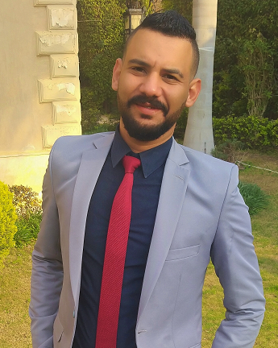

**◆ Career Objective:**

Seeking a dynamic position and challenging career with reputable organization where my academic background and interpersonal skills would be exposed to a challenging work environment, allowing room for self- development and open career path.

**◆ Personal Information**

**Name:** Ahmed Hassan Ali Hassan

**Date of Birth:** 1st of November 1990

**Age:** 28 years’ old

**Nationality:** Egyptian

**Military Service:** Completed

**Marital state:** Single

**Language:**

Arabic Mother tongue

excellent English written, good English spoken

**Address:** Compound Ramses Residence, Investors district 5.

Villa 6, El Shrouk City.

**Mobile number:** 01060073393

**e-mail:** [a.hassan_90@hotmail.com](mailto:a.hassan_90@hotmail.com)

**( private car license and got a car )**

**◆ Certificate**

Academic degree in Business administration

(Major) Marketing & management from Arab Open University (AOU)

Marketing & management Certificate from Open University UK

**◆ Other Certificate**

❖ Human Resource Diploma from the Canadian Training Centre

❖ Project Management: The Basics for Success

from University of California, Irvine

◆ **Computer Skills:**

Excellent knowledge of Microsoft Windows

Excellent knowledge of Microsoft Office (Word, Excel, Power Point)

Excellent knowledge of Internet applications

◆ **Other skills**

❖ online marketing & Selling Skills

❖ Communication & Negotiation skills

❖ internet self-studding and research’s

❖ social media advertising and fb ads

◆ **Work Experience:**

❖ from August 2020 till now own and operate a wedding planning business called

" EventRix "

❖ from January 2020 to September 2020 real estate sales representative at landmark property finder

❖ from august 2019 till December 2019 Delivery associate at “ Breadfast “

❖ April 2019 – November 2019 Branch Manager at “Olio Frozen Food Company “

❖ march 2016 – November 2016 Branch Manager at stationery house called “ i-Book “ located in Madinaty

❖ October 2015 - January 2016: Sales Representatives at " El Deeb Academy " Health Club

❖ 2013 till 2015

Field worker’s coordinator in " Pioneer for construction and Decoration "

◆ **other Work Experience:**

❖ ushering in different events with (red bull & Winston tobacco)

❖ distribution seller on clothing industry

❖ network marketing and selling online, social media marketing

❖ Uber driver from time to time