**Hossam Eldin Mohamed Ahmed**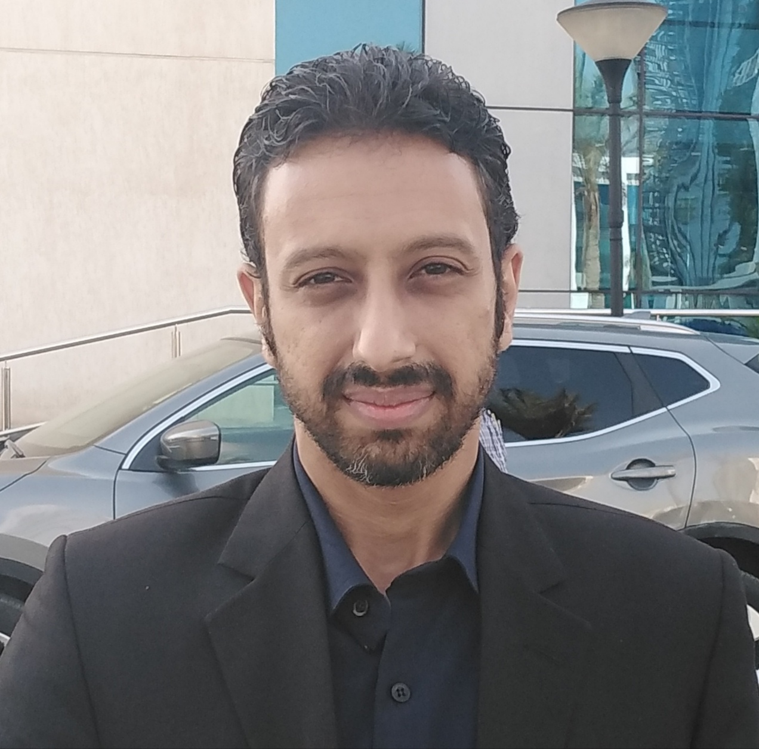

**Masakin Sakiet Maki 136 / Giza**

**01273865006**

**E-mail :hossammohamed18887@gmail.com**

**EDUCATION:**

**- Elgazeera Academy – May 2007**

**- BA in management information systems**

**(equivalent Business Management)**

**- Overall Assessment / *very good***

**Language :**

**Arabic : mother tongue**

**English : Good command of both written and spoken English**

**Personal Date :**

**Date of Birth : 7 / 1 / 1986**

**Nationality : Egyptian**

**Marital Status : Single**

**Religion : Muslim**

**Military service : Military service done**

**Experiences :**

* ***Recepion and Office manger***

**(The grocer Market & Magma Sport wear "Elsewdy Electric") 2022**

* ***Quality control & customer service* Alfa market) 2019-2021**
* ***Branch official* (Aman Financial Services Services "Raya") 2018-2019**

* ***Office Manager* (Alahd Real Estate) 2015-2018**
* ***Recepion and Executive Secretary***

**2012-2015 (Delta Real Estate )**

* ***Accountant* (floating Hotel Queen NeferІІ) 2008**
* ***Customer service* (Etisalat Egypt) 2007**

**PROFESSIONAL COURSES:**

**- Education : 2006 Plenary session in**

**(Introduction – Windows – Office –Internet)**

**Personal skills:**

**• Communicate effectively with colleagues to coordinate  
• Establishing and maintaining effective working relationships  
• ability to work with other in a team environment and achieve common goals  
• The ability to deal with stressful situations**