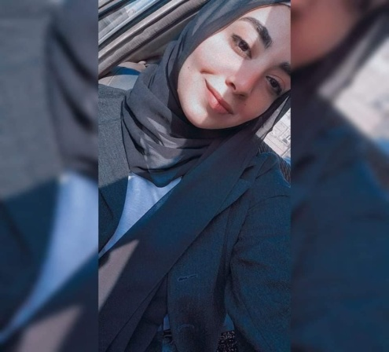 | Omnia tarek eid  shoubra – cairo  Cairo, Egypt.  +201507227080 - 01140523186   beoptimistic8fa@gmail.com
ㅡ  Personal information | Graduated from a 4- year course in agriculture & agriculture engineering in 2023.trained to work in high – stress environments and stay calm under pressure. Seeking to leverage meticulous record – keeping and analytical skills to gain experience as a engineering
ㅡ  License and certification | Bachelor’s degree of agricultural engineering in Ain Shams university – very good (GPA 2.8)  Auto CAD 2D
ㅡ  Experience | - Training in land master company (TMG) department : agriculture & irrigation  From 1-8-2023 to 15-8-2023  - Auto CAD 2D with grade Excellent  - From 25-10-2022 to 1-12-2022  - Training in agriculture professions syndicate in designing irrigation networks and water needs from 31-10-2021 to 1-11-2021  - Training in badar university (BUA)in landscape from 10-9-2022 to 16-9-2022
ㅡ  Skills | Language skills:  Arabic :mother tongue.  English: good command reading, writing, listening and speaking).  Computer skills:  Excellent user of Mycroft Office (Excel , Word )  Additional skills:  -Presentation skills  -Effective communicator.  -Ability to handle stressful situations.  -Critical thinking skills; ability to address emergency situ ation and come up with effective solutions.  -Flexibility and ability to adopt any situation  -Ability to make quick informed decisions.

ㅡ  References | Available upon request.

