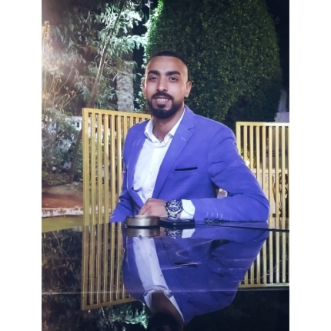

**Mohamed Elaraby**

Irrigation & landscape engineer

Highly motivated fresh graduate skilled in Microsoft office program, customer service, administration and management Experience in management and team leadership and always highly committed to the work and looking forward for an organization where I can grow professionally by utilizing my knowledge & skills.



**PROFIL**



**communication**

**NAME Mohamed Gamal Elaraby**

**PHONE 01124249317**

**EMAIL** [**m.el3araby16@gmail.com**](mailto:m.el3araby16@gmail.com)[**Mohamed_gamal2282@yahoo.com**](mailto:Mohamed_gamal2282@yahoo.com)

[WWW.HELPSHARED.COM](https://www.helpshared.com/2015/12/contoh-cv-lamaran-kerja-menarik-desain.html)

**Education**



 **Bachelor's degree in agricultural engineering (G.Y) // 2023**

**Ain-Shams University**



**Experience**

 **landscape engineer // January 2024 - march 2024**

**New Cairo Contracting Company**

• Site Engineer, work was done on maintaining the irrigation and agriculture network on 44th Street in the Administrative Capital.

• Hardscape Construction Site Engineer, the construction site was received and work was completed on the hardscape in the Al-Muthannat area inside the military entity in the Administrative Capital.

• Construction site was received and work was done on the softscape

• And hardscape site for the leaders' villas in the military entity in the Administrative Capital.

• Construction zone was received in the officers' buildings in Al-Nargis Compound in the military entity and work was done on establishing the hardscape and the entire irrigation network until the end



**computer**

**AutoCad**



**Microsoft office**